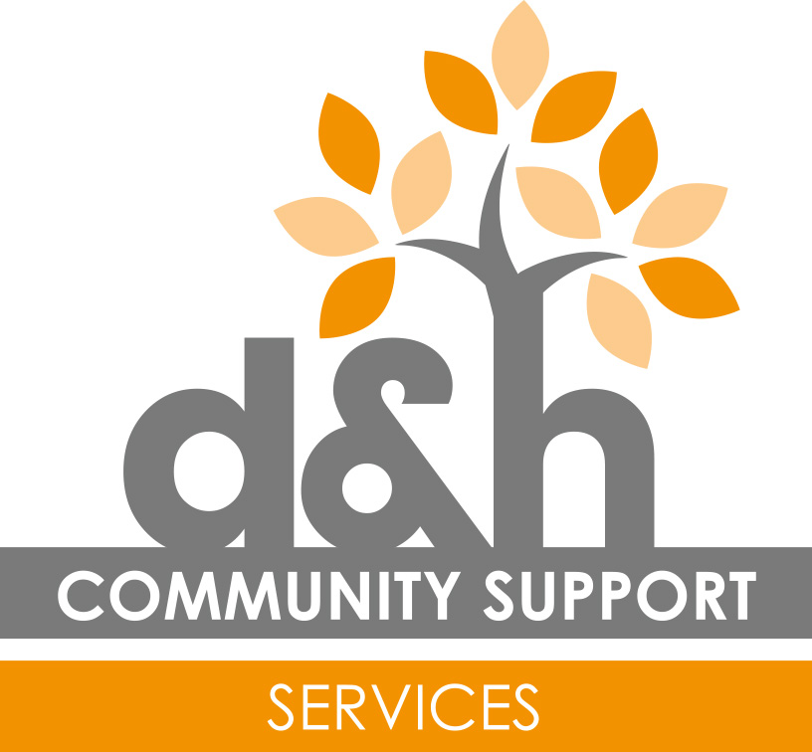

D&H Community Support Ltd.
Services for People with Disabilities

Job Title: Community Links Worker.

Responsible To: Directors, Managers and Seniors of D&H Community Support.

Primary Objectives: To work as part of D&H Community Support Ltd delivering a person-centred service.
To support our customers to be as independent as possible and be part of the community, encouraging social inclusion.
To work in a way that creates a culture which values, respects and promotes the privacy, dignity, rights, health and wellbeing of people who need care and support.

Duties/Responsibilities:

- To provide individuals with care and support in a person-centred way and within the aims, objectives and principles of D&H Community Support (as outlined in the Employee Handbook).

- Promote independence and development of appropriate skills and relationships to enable people with disabilities to make full use of community facilities and engagement.

- To support the individual to contribute and implement their Person-centred Plan, Health Action Plans and Support Plan.

- Plan, prepare and implement activities for individuals and groups to meet physical, emotional, intellectual and social needs.

- Ensure the personal care, nutrition, hygiene and medication needs of the individuals are met sensitively and with respect.

- To support customers into education, voluntary and/or paid work opportunities where appropriate.

- To be aware of and work within Safeguarding procedures and report any concerns of abuse to a D&H Manager/Senior.

- Contribute to and implement Positive Behaviour Management Plans as appropriate in a positive way that ensures the person is valued and respected.

- To contribute positively to the effectiveness of the team, showing courtesy and respect for work colleagues (staff & volunteers). To share knowledge and experience with colleagues as required.

- To work to an agreed rota, report absences or change of circumstances in a timely way.

- To support and contribute to the development of networks with other partners such as Local Authorities, Health, Volunteer organisations, other employers, leisure and education providers, etc.

- To communicate appropriately and effectively with customers, carers and other professionals, upholding the integrity of D&H.

- To work within D&H Community Support Ltd. Policies and Procedures at all times; if unsure speak to a line manager.

- Contribute to the identification of risks and the development of effective risk assessments. To report any concerns or the need for a risk assessment to your line manager.

- To undertake administrative procedures to a high standard, completing customer records, reports, PCP’s, activity plans, etc.

- To participate in staff supervision, development and training as and when required.

- To ensure provision of transport for individuals, through provided transport and staff members’ own vehicles.

- To assist in the daily preparation of providing a service, ensuring the premises are ready to receive customers in a courteous and welcoming manner.

- To undertake general cleaning and catering duties associated with the running of the service, where necessary.

- To ensure a safe working environment in accordance with Health and Safety Regulations.

- To attend staff meetings.

- To comply with the data protection regulations, ensuring that information on customers remains confidential.

- To conform to Equal Opportunities Law and promote equality, diversity and inclusion by treating all people fairly and without bias.

- To undertake any other duties or projects commensurate with the nature and grade of this post as required.
This job description is not exhaustive and serves only to highlight the main requirements of the post holder. The line manager may stipulate other reasonable requirements. The job description will be reviewed regularly and may be subject to change.

Reviewed Oct 2016

