- I love making people feel valued. | 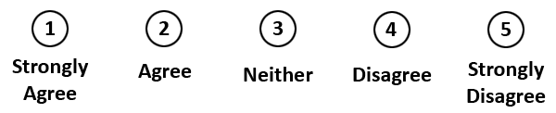
- I love to go that extra mile for people.
- I love making a difference to people.
- I am a caring person.
- I am very reliable.
COMPANY LOGO

